James Young Take Home Test 4

**(a) Write the model for this experiment. Identify all terms and indices. What is the experimental unit?**

$$y_{ijk}=μ+α_{i}+γ_{j}+β_{k}+ε_{ijk}$$

where $y_{ij}$ =observed response for treatment i in block j; μ =reference value (overall mean); $α_{i}$ =effect of fertilizer treatment, i=1,2,3,4 (control, granular, pellet, liquid); $γ_{k} effect of water treatment, j=1,2 (yes,no) β_{k}$ =effect of block k, k =1,2,3,4,5; and $ε_{ijk}$ =experimental(random) error. The experimental unit is a pot.

**(b) Perform a Stage One analysis with 𝑏 blocks and all 𝑎 × 𝑐 factor level combinations as**

**treatments.**

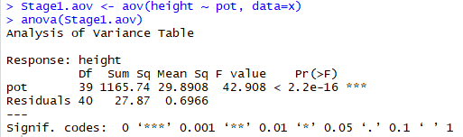

**(c) Perform a Stage Two analysis that partitions the treatment sum of squares according to the factorial structure.**

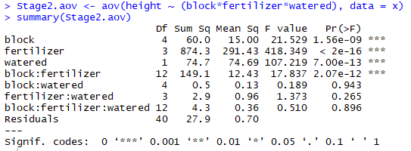

**(d) Perform a Final Stage analysis that combines the results of the first two stages and uses the appropriate experimental error to test main effects and interaction. Provide a complete**

**ANOVA table for this Final Stage using the table provided (hand written).**

|  |  |  |  |  |
| --- | --- | --- | --- | --- |
|  |  |  |  |  |
|  |  |  |  |  |
|  |  |  |  |  |
|  |  |  |  |  |
|  |  |  |  |  |
|  |  |  |  |  |
|  |  |  |  |  |
|  |  |  |  |  |
|  |  |  |  |  |
|  |  |  |  |  |

**(e) State each hypothesis, use the p-value to test at a significance level of 𝛼 = 0.05, provide the decision rule, and a conclusion in the context of this problem.**

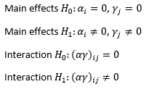Based on P-values from part (c).

Main Effects: Calculated p-value for fertilizer <2e-16 and water was

7.00e-13. Both main effect p-values <0.05, therefore we reject H0 and

Conclude that fertilizer and water are significant to plant height response.

Interaction: Calculated p-value for block:fertilizer = 2.07e-12. 2.07e-12 <0.05, therefore we reject H0 and

conclude that interaction is significant to plant height response.

R-code appendix

### Take Home 4

setwd("C:\\data\\")

x <- read.csv("data-takehome4.csv")

# summary(data)

# colnames(data)

# Note: create factors for Stage 1 and Stage 2 ANOVA

x$block <- as.factor(x$block)

x$pot <- as.factor(x$pot)

x$cell <- as.factor(paste(x$block,x$pot, sep='.'))

x$cell <- as.factor(paste(x$block,x$watered, x$fertilizer,sep='.'))

### ANOVA

# Stage 1 between cell analysis

Stage1.aov <- aov(height ~ pot, data=x)

summary(Stage1.aov)

anova(Stage1.aov)

# Stage 2 Partition Sums of Squares

Stage2.aov <- aov(height ~ (block*fertilizer*watered), data = x)

summary(Stage2.aov)

model.treatments <- aov(height ~ fertilizer+watered + block + Error(block/(watered+fertilizer)), data=x)

summary(model.treatments)